GINGERBREAD TIPS & TRICKS
BY THE GINGERBREAD LADY
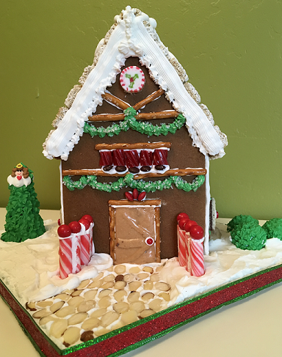
This Gingerbread House was made with:

Ice cream cone
Pretzels
Bit O Honey candy
Red M & M's
Brown M & M's
Candy Canes
Chocolate Balls
Licorice
Gum Balls
Christmas Peppermint
Decoration Perils
Vanilla Chocolate Wafer Cookies
Mini Wheat Cereal
Sliced Almonds
Specialty Pressed Sugars
Banana Taffy
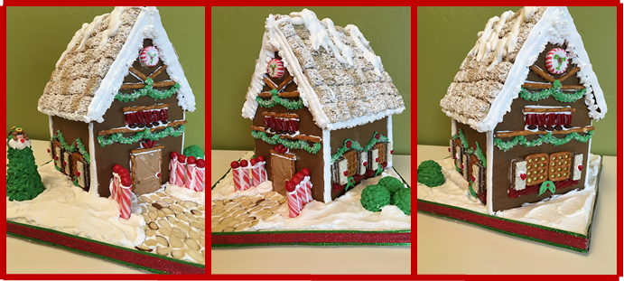
And Royal Fros

Start with an Idea and Pattern
THE UGLY SWEATER COMPANY

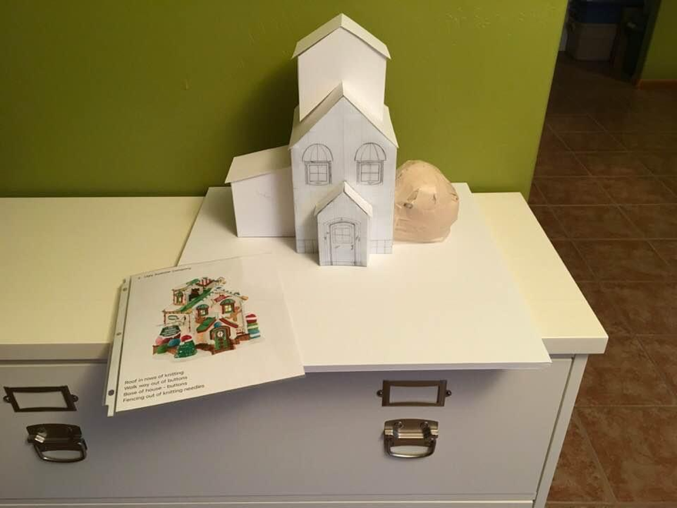
Once I have an idea of what I want to make, I make my pattern. I like to use Bristol drawing paper because it’s super thick paper and easy to cut. You can use cardboard or foamboard. By using the thick paper I do have to adjust my measurements for the thickness of the gingerbread. If I don’t my roof won’t fit properly.

I like to draw in the windows and doors and any other detail to help guide me when I cut out my gingerbread.

Next, I tape the pattern together to make a model and place on my base to make sure it will fit.

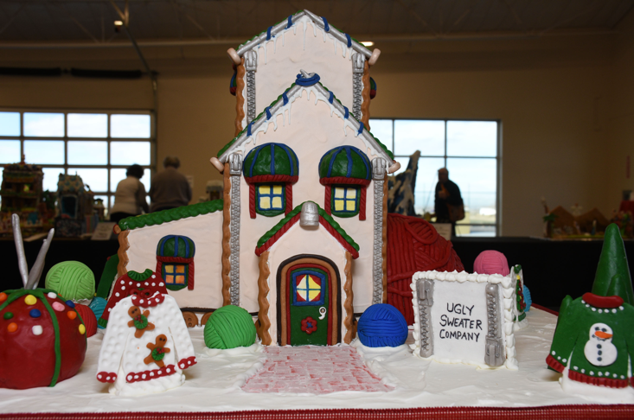
For my base, I use ½ inch foamboard and glue small squares of ¼ inch foamboard underneath to create “legs.” This helps me move the piece as I work on it, it gives room for my fingers! Make sure your base is large enough to hold the weight of the gingerbread piece.

Next, the “yard” or what I call the yard. Where will the walkway go? Trees? Fence? Or any other details you want to tell you gingerbread story.
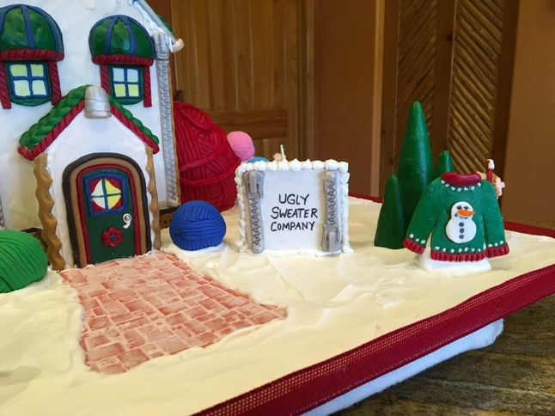

Your building process may not go as planned, a window or dormer does not fit, walls are not straight, I’ve even glued on windows upside down and did not notice until it was too late to fix. Don’t stress, with gingerbread you can easily make a change, adjust the size or style and cover up most mistakes.
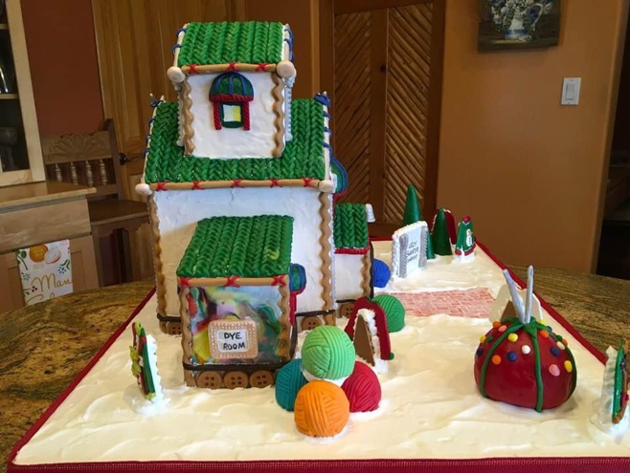

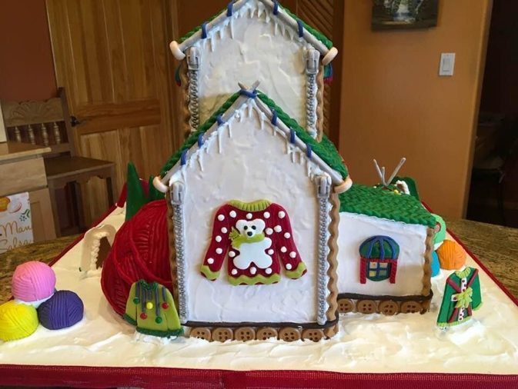

Gingerbread Dough
1/3 cup soft shortening
1 cup brown sugar (packed)
1 ½ cups dark molasses - 12 oz.
2/3 cup cold water
7 cups flour
1 tsp. baking soda
1 tsp. each – salt, allspice, ginger, ground cloves, cinnamon

Cream shortening; add brown sugar and molasses and mix thoroughly. Combine flour, baking soda and spices. Alternate adding water & dry ingredients into molasses mixture, stopping a couple of times to scrap down inside of mixing bowl. Dough will be very firm, so if your mixer begins laboring before all the dry ingredients are added, knead the remaining dry ingredients in by hand. Place dough in plastic bag, squeeze out all the air and chill for a minimum of 24 hours. You can chill up to 48 hours to 1 week before using. Before rolling, let the dough warm up a bit.

Bake in a pre-heated oven 350 degrees for 10 to 12 minutes or until edges start lightly browning.

Royal Icing

3 egg whites at room temperature
1lb of powdered sugar
1/8 tsp. cream of tartar

Put egg whites in mixing bowl; then powdered sugar and cream of tartar. Mix on low until blended. Once blended, switch to high speed and mix for 6 minutes. Icing will turn very white and stiff.
Icing can be kept in air tight container for up to 2 days in refrigerator.

Tips:
- When storing Royal Icing, place plastic wrap directly on top of icing, pushing all the air out, then cover.
- Whip icing that has been stored to bring back stiffness.
- If icing is to dry add more egg whites, if too wet add more powdered sugar.
- Wrap piping ends with damp paper towel between decorating to prevent hardening.
- Allow house to dry completely before adding decorations –minimum 4 hours.
- Use a rubber band on the top of your pastry bag to keep icing from oozing out.

Filling a Pastry/Frosting Bag
- Cuff bag top over one hand while using your other hand to scoop in icing with spatula.
- Don’t fill bag more than ½ way full of frosting.
- Unfold cuff and twist top of bag closed, forcing icing down into bag and decorating tip.
- Release air bubbles before decorating by holding bag over icing bowl and squeezing until air is released.

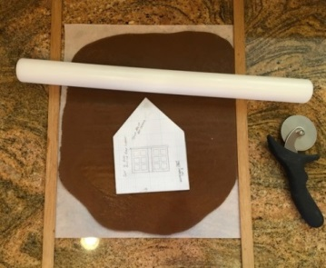
Rolling out your gingerbread dough:

- Roll your dough out onto parchment paper, not waxed paper.
- Use a good rolling pin.
- Dust your parchment paper with a little flour to help roll out dough. Use as little flour as possible when prepping to roll, it dries out your dough and causes crack during baking.
- To get the same thickness throughout your dough when rolling out, place flat sticks on either side of your dough. I used 1/8th inch pottery sticks that are used when rolling out clay. Yard sticks will work too.
- Make sure to space your pattern pieces with enough space around each piece so when you go to cut them out have enough room.
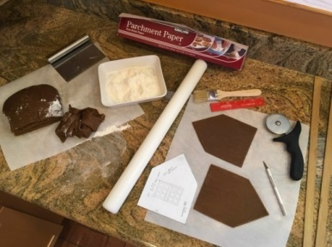
- Use pizza cutter for straight edges, exacto knife for curved pieces. With exacto knife don’t press to hard you’ll cut through the parchment paper and score your counter.
- Don’t remove excess gingerbread until you have scored all pieces as it can cause pieces to move.
- Using a small, clean brush, dust away any excess flour. I use a BBQ brush. Make sure it’s not been used before as it will have collected oil and the flour will stick to the brush.
- Slide parchment paper with cut dough onto cookie sheet.

Cooling your gingerbread dough:
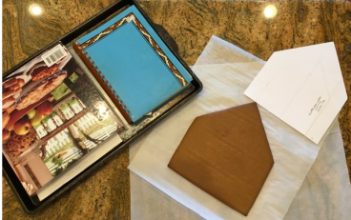
- Don’t use a wire rack to cool pieces this will cause them to curl and cause lines.
- Slide the parchment paper with baked pieces onto your counter, place a larger, clean parchment paper on top of your baked pieces, grab both parchment pieces between your fingers and flip over quickly. Place a cookie sheet with books on top to keep pieces from curling. Let pieces cool completely.
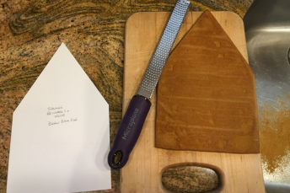
- When cool, place pattern piece on top of each piece. This helps when you go to build your house to know which piece is which, especially if you have multiple pieces of the same shape.
- Let pieces dry for 24 hours before putting together your house.
- You can bake your pieces well in advance of building your gingerbread house, extra drying never hurts. Just keep them covered, and flat.

Building your Gingerbread House:

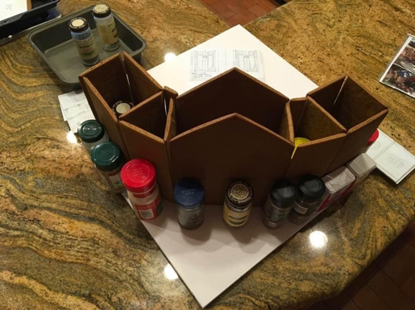
- Most gingerbread pieces don’t bake straight. You can use a microplane to shave and shape edges. Be careful. Make sure to place your piece on a flat surface so you don’t break the piece.
- Always dry fit your pieces on your base to make sure they will fit together. You can always shave down the edges a little more if needed.
- Have plenty of helpers on hand – spice bottles, jello boxes and soup cans work well!

Chocolate Clay

Chocolate clay, I love chocolate clay! It’s easy to make, comes in multiple colors, you can make up your own colors and you can do almost anything with it….trees, doors, windows, roof, walkways and much more.

- 1 Bag of purchased Candy Melts, Welton is my favorite. Place in microwaveable dish, cook for 1 minute. (Microwave time may vary).
- Mix melted chocolate until smooth
- Add 1/3 cup of light corn syrup, food coloring if mixing your own color, mix well
- Turn on plastic wrap to let cool
- Kneed a bit through the plastic wrap, cover completely and tightly then let rest/cool overnight.
- Once rested you can use just like clay, cutting with cookie cutters, shaping, you can even use in an extruder!
- Chocolate clay will get warm as you use it. If it get too warm to use, let it rest to get back to room temperature or place in refrigerator for a couple minutes.

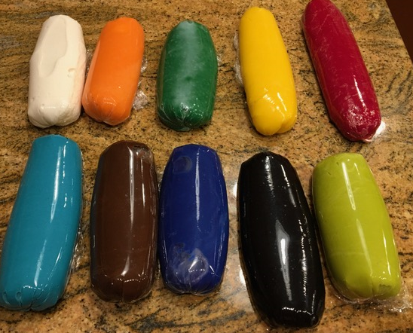

Walls – Plain or Covered

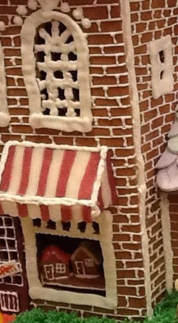
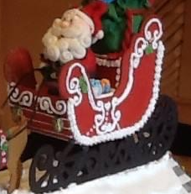
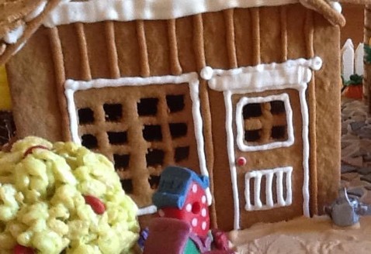
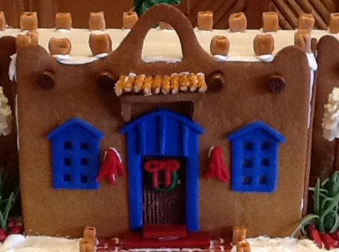
When mapping out your design you need to ask yourself plain or not plain? Do you want your walls to be plain gingerbread or decorated. Here are some ideas using plain gingerbread.

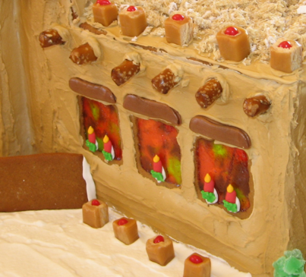
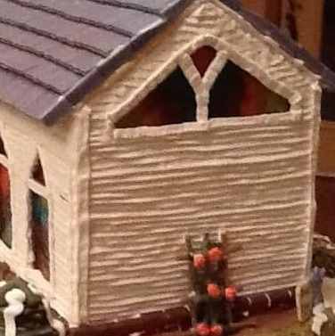
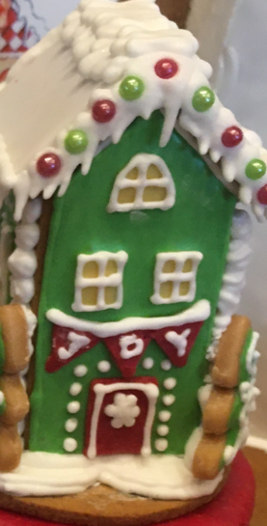
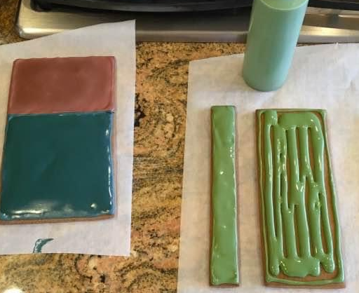
If you plan on covering your walls you an use royal icing……

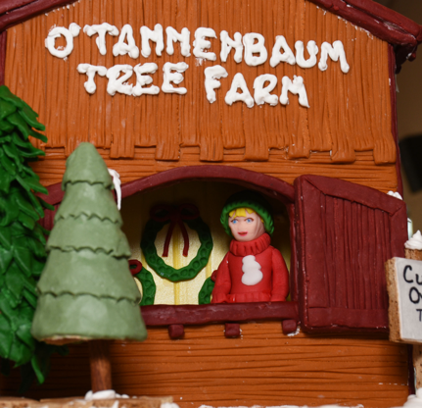
or my favorite…chocolate clay and colored fondant.
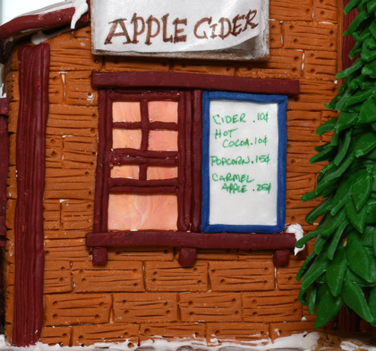
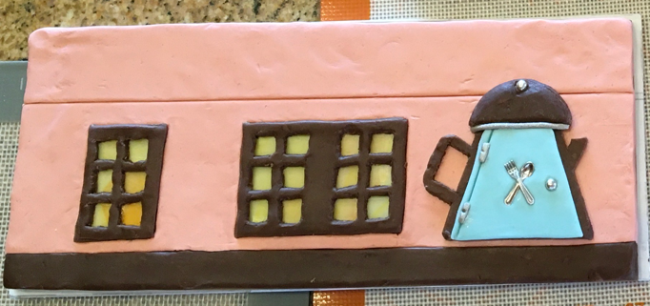

Windows & Doors
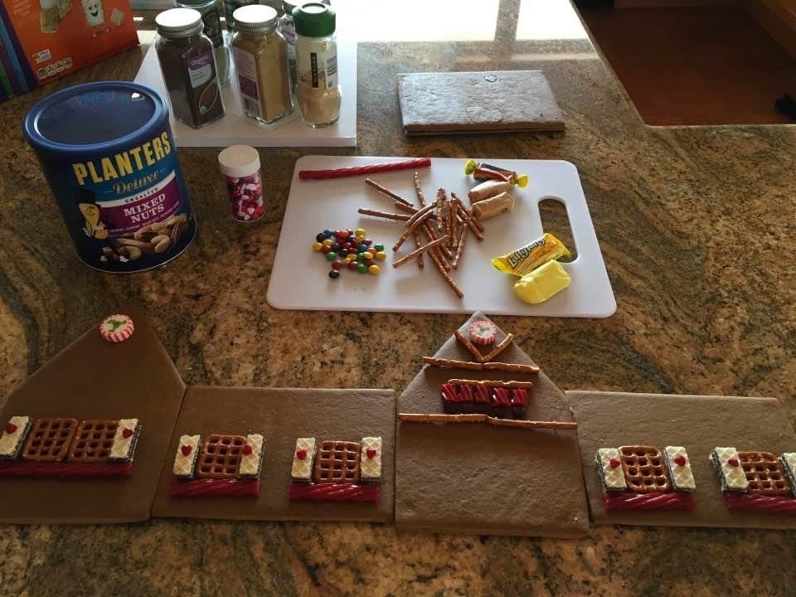
Windows and doors give your gingerbread house character. You can make them any shape you want - square, round, triangle, single pane or multi-pane; cut them out, back-fill them, and frame them.

The best way to work on your windows and doors and other elements is when your piece is flat. Once you have all windows and doors in place, then you can put your house together. Be careful so you don’t break any of your details off.

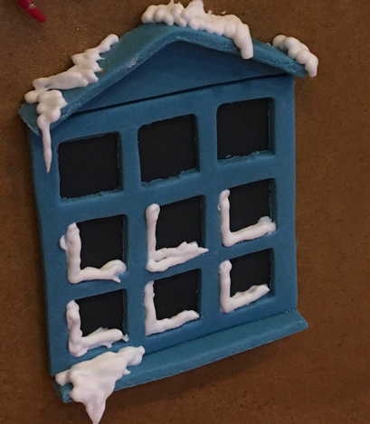
You can make your windows, and doors out of pretzels, gum, taffy, rolled caramels or any other ideas you might have with purchased food items. Chocolate clay and colored fondant work great too.
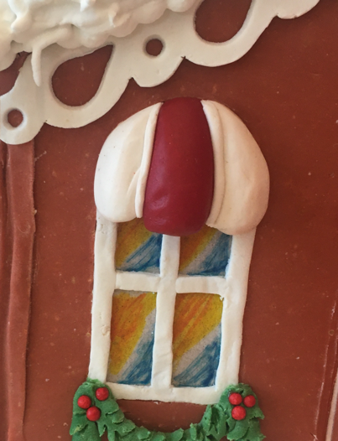
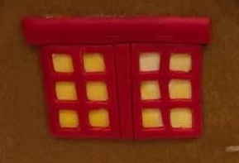
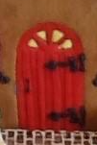
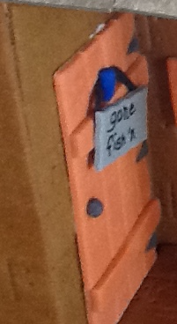
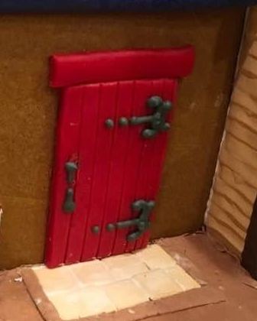

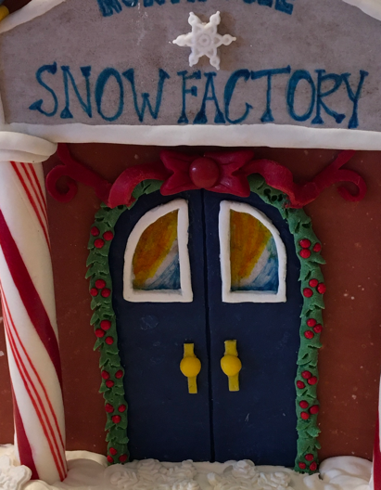
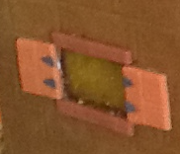

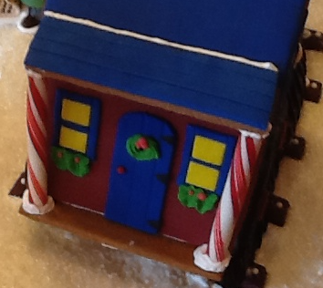
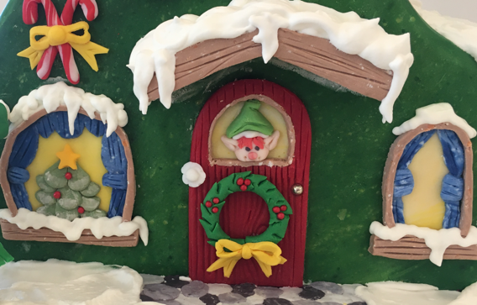
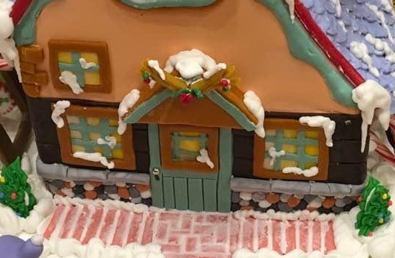

Trees & Bushes

Trees and bushes in your “yard” help polish your design and add to your design story. Most cone trees are made with sugar cones or waffle cones piped with green frosting. You can leave plain or decorate with sanding sugar, or colored candy perils.

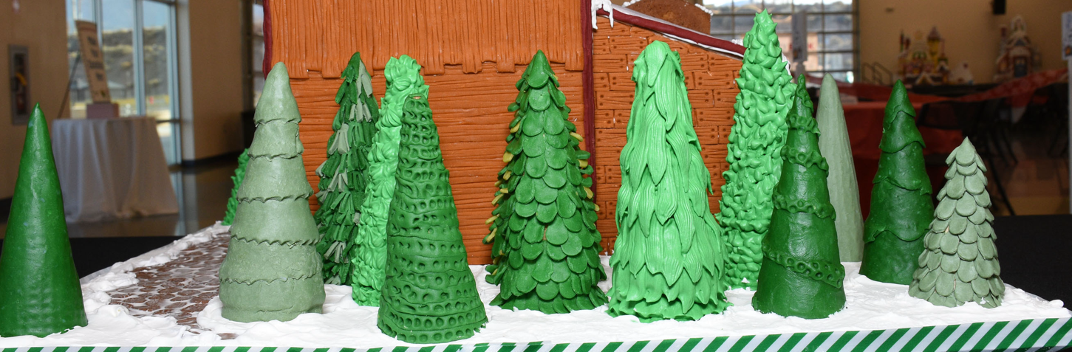
Chocolate clay and fondant works great for trees & bushes too. Using a small cookie cutter leaf shape, cut out and adhere with royal frosting. Using different colors of green can help make your trees and bushes stand out.
Rice crispy treat recipe work well too….but you need to use the recipe below as the store bought treat won’t harden.

Rice Crispy Recipe:

This rice crispy treat recipe is a little different from the published recipe on the box of cereal. If you use that recipe your mix won’t harden. You can tint any color you wish, and can use a variety of cereal, not just rice crispy cereal for added shape. You can have edible, uniquely shaped bush or tree.

1 ½ TBLS of Vegetable Shortening
20 regular size marshmallows or 2 cups mini marshmallows
3 Cups rice crispy cereal or cornflakes

In large saucepan over low heat. Melt shortening, add marshmallows and stir until completely melted. Add food coloring. Remove from heat. Add your choice of cereal. Stir until well coated. Let cool for a minute or so (but not too long or it will harden in the pan).
WITH YOUR HANDS COATED WITH BUTTER or MARGARINE (so the mix won't stick to hands), scoop out the amount you want and form into a bush or tree. You have to work fast. It also helps to place bushes on a glob of frosting so they will stick to the "yard".

Roofing Ideas

When decorating your roof be careful not to pick a covering that is heavy it will out weight your roof causing it to cave in. To make roof tiles for your Gingerbread house, run a line of frosting across the bottom edge of your roof. Place the first row of crackers/candy at the bottom edge of your roof. For the second row, offset the "shingles" by starting with 1/2 a "shingle". Continue until your roof is covered.
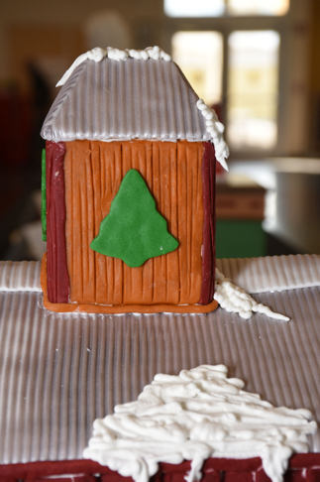

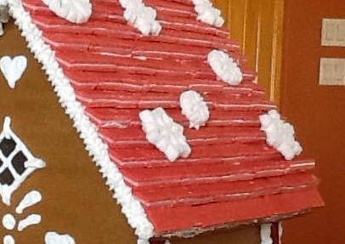
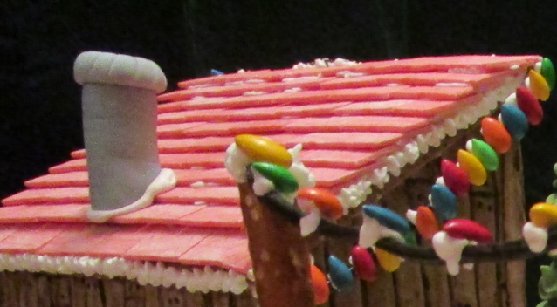
Some of my favorite things are Crackers or Cereal, Necco Wafers, gum, or chocolate clay.
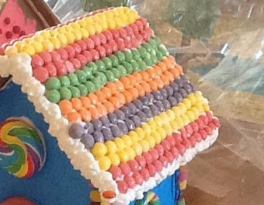

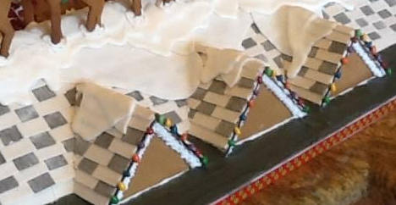
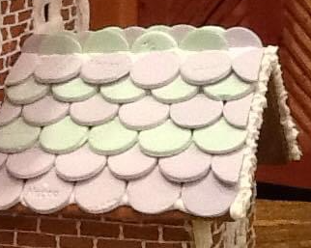
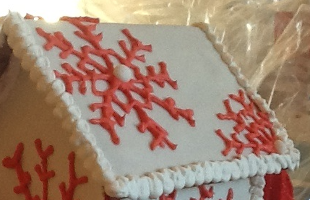
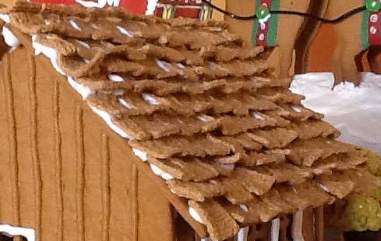

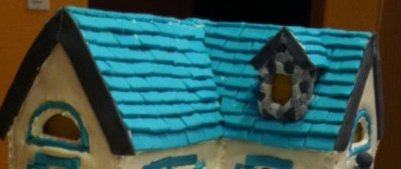
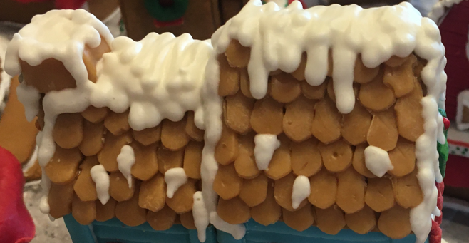

Paths and Walkways

An easy way to create a path or walkway is to draw it out on your base or spread a good amount of frosting in the shape of your path or walkway. Now press the candy into the frosting. The frosting will fill-in around the edges, forming a mortar between the candy pieces. My favorite walkway things are tootsie rolls, gum, chocolate clay or colored fondant with a brick mold.

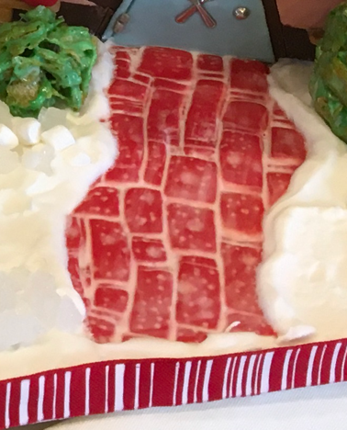
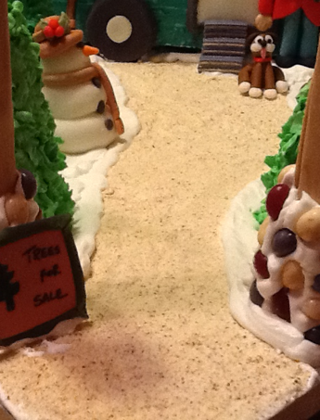
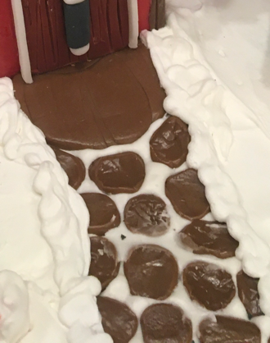

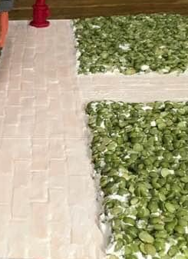
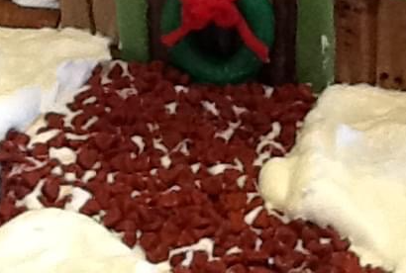
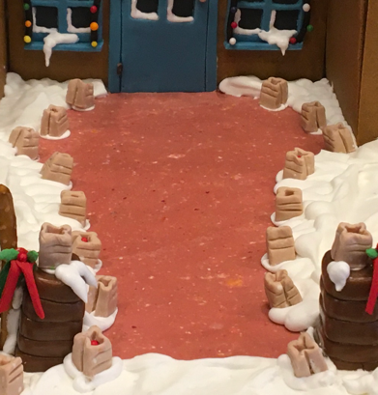

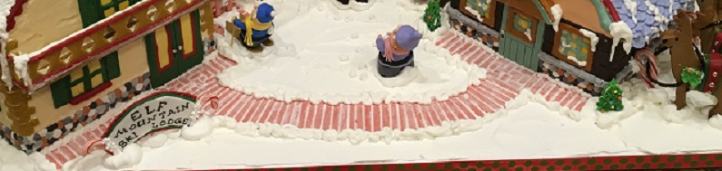

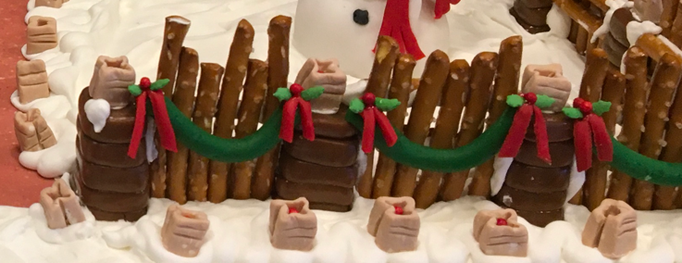
Fencing

Don’t be afraid to be creative, what one person sees as a fence another will see as a tree. Both are right! Your fencing, if you are making a fence can be made out of many things, gingerbread, rice crispy treats, tootsie rolls, pretzels, candy, and even royal icing!

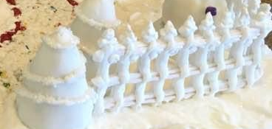
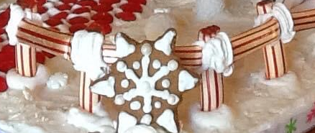

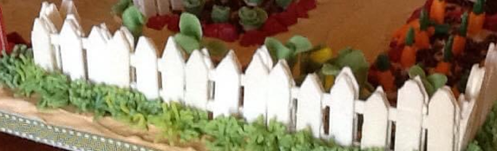
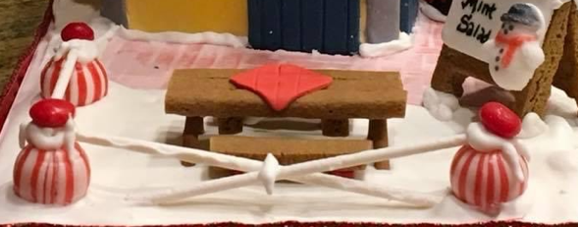

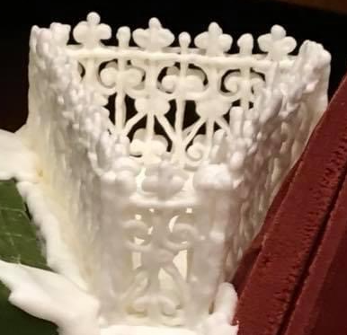

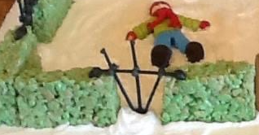

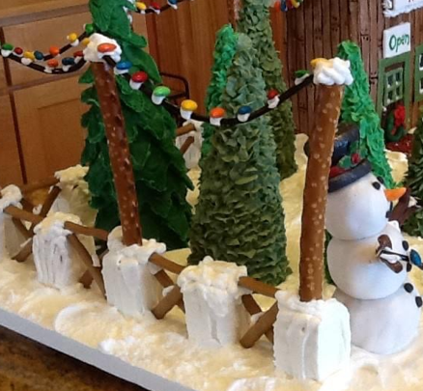
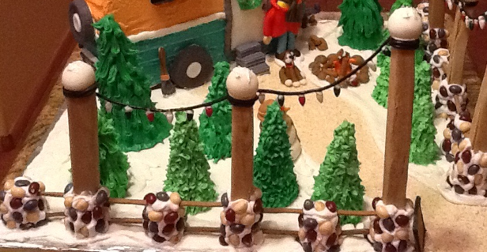


Fun Elements

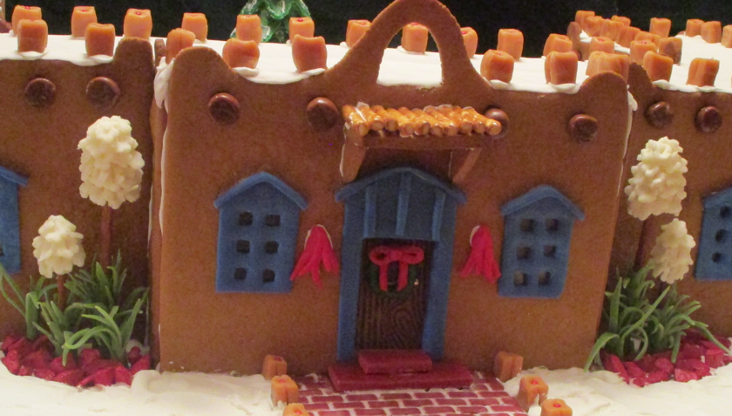
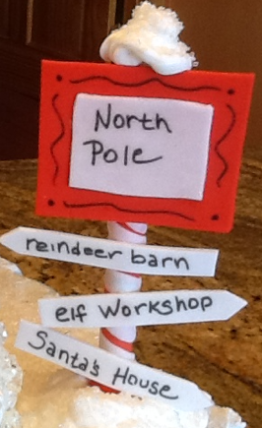
I like to include fun elements in my design to help tell the story of my creation. Your fun element can be signs, snowmen, Santa, Elves….anything to make it fun to look at and add excitement to your design.
