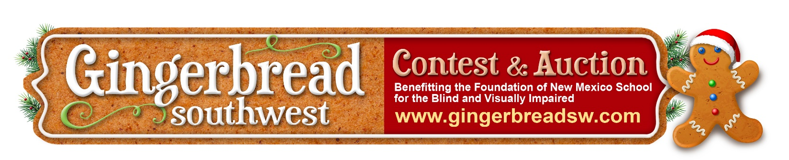

**Sponsorship Opportunities**

***For your support, you will receive…***

|  |  |
| --- | --- |
| **Christmas Angel**  **$5,000** | * Your business name/logo on event materials, events and website * 20 tickets to the Auction & Awards event * Large (full page) recognition in our event program |

|  |  |
| --- | --- |
| **Holly Jolly**  **$2,000** | * Your business name/logo on event materials, events and website * 10 tickets to the Auction & Awards event * Medium (half page) recognition in our event program |

|  |  |
| --- | --- |
| **Santa & Mrs. Claus**  **$1,000** | * Your business name/logo on event materials, events and website * 6 tickets to the Auction & Awards event * Medium (half page) recognition in our event program |

|  |  |
| --- | --- |
| **Frosty the Snowman $750** | * Your business name/logo on event materials, events and website * 4 tickets to the Auction & Awards event * Small (quarter page) recognition in our event program |

|  |  |
| --- | --- |
| **People’s Choice Award $500** | * Your business name/logo on event materials, events and website * 2 tickets to the Auction & Awards event * Small (quarter page) recognition in our event program |

|  |  |
| --- | --- |
| **Helper Elves $250** | * Your business name/logo on event materials, events and website * 2 tickets to the Auction & Awards event * Recognition listing in our event program |

**If you have any questions, please contact Linda Lyle at 505-331-3821.**  
**Sponsorships due by Wednesday November 18, 2024**



**Sponsorship Payment:**

**To pay by credit card**, please submit your sponsorship request and pay via our website: **www.GINGERBREADSW.com**

**If you prefer to pay by check**, please complete the sponsorship form below and mail your check to:

**NMSBVI Foundation**

**801 Stephen Moody St. SE**

**Albuquerque, NM. 87123**

*Please make checks payable to* ***NMSBVI Foundation****.*

***YES! I am happy to sponsor the 2nd Annual Gingerbread Southwest at the level indicated below*** *(please check one)****….***

Sponsor Company Name:__________________________________________________________

Contact Name: __________________________________________________________________

Address: _______________________________________________________________________

Phone: ________________________________

Email: _____________________________________________

**Sponsorships:**

Christmas Angel - $5,000

Holly Jolly - $2,000

Santa & Mrs. Claus - $1,000

Frosty the Snowman - $750

People’s Choice Award - $500

Helper Elves - $250

Please accept my non-sponsorship donation of $_____________

***Please include sponsorship form with your check.*  
Sponsorships due by Wednesday November 18, 2024**